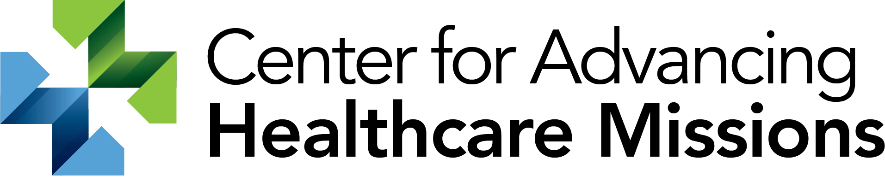

PSLF / IBR next steps

-Direct loan consolidation- https://studentaid.gov/app/launchConsolidation.action
-PSLF- https://studentaid.gov/manage-loans/forgiveness-cancellation/public-service
-IBR- https://studentaid.gov/manage-loans/repayment/plans/income-driven
-Student aid loan simulator- https://studentaid.gov/loan-simulator/#view-repayment-plans
-Student loan repayment calculator- https://studentloanhero.com/calculators/student-loan-income-based-repayment-calculator/
https://finaid.org/
If you think you’re ready to move forward, there are 5 steps…
- Research and ensure you understand the program
- Consolidate loan
- Apply for IBR
- Annually- submit documentation (plus whenever you change jobs) for PSLF and recertify IBR
- Start counting down the 120 months until you’re done with student loans!

Contact info
Doug Lindberg, MD
Director, CMDA Center for Advancing Healthcare Missions
doug.lindberg@cmda.org

