Resources
Organizations at GMHC with Allied Health Opportunities (not exhaustive):
- SIMS (https://www.simusa.org)
- Samaritan’s Purse (limited allied health opportunities, https://www.samaritanspurse.org/medical/world-medical-mission/)
- Orphan Voice (https://orphanvoice.org)
- Mercy Ships (https://www.mercyships.org)
- OMF (https://omf.org)
- Interserve (https://www.interserve.org)
- CPRP of CMDA (https://cmda.org/specialty-sections/christian-physical-rehab-professionals/)
- Scatter Global (https://www.scatterglobal.com/)
Comparison of Select Organizations:
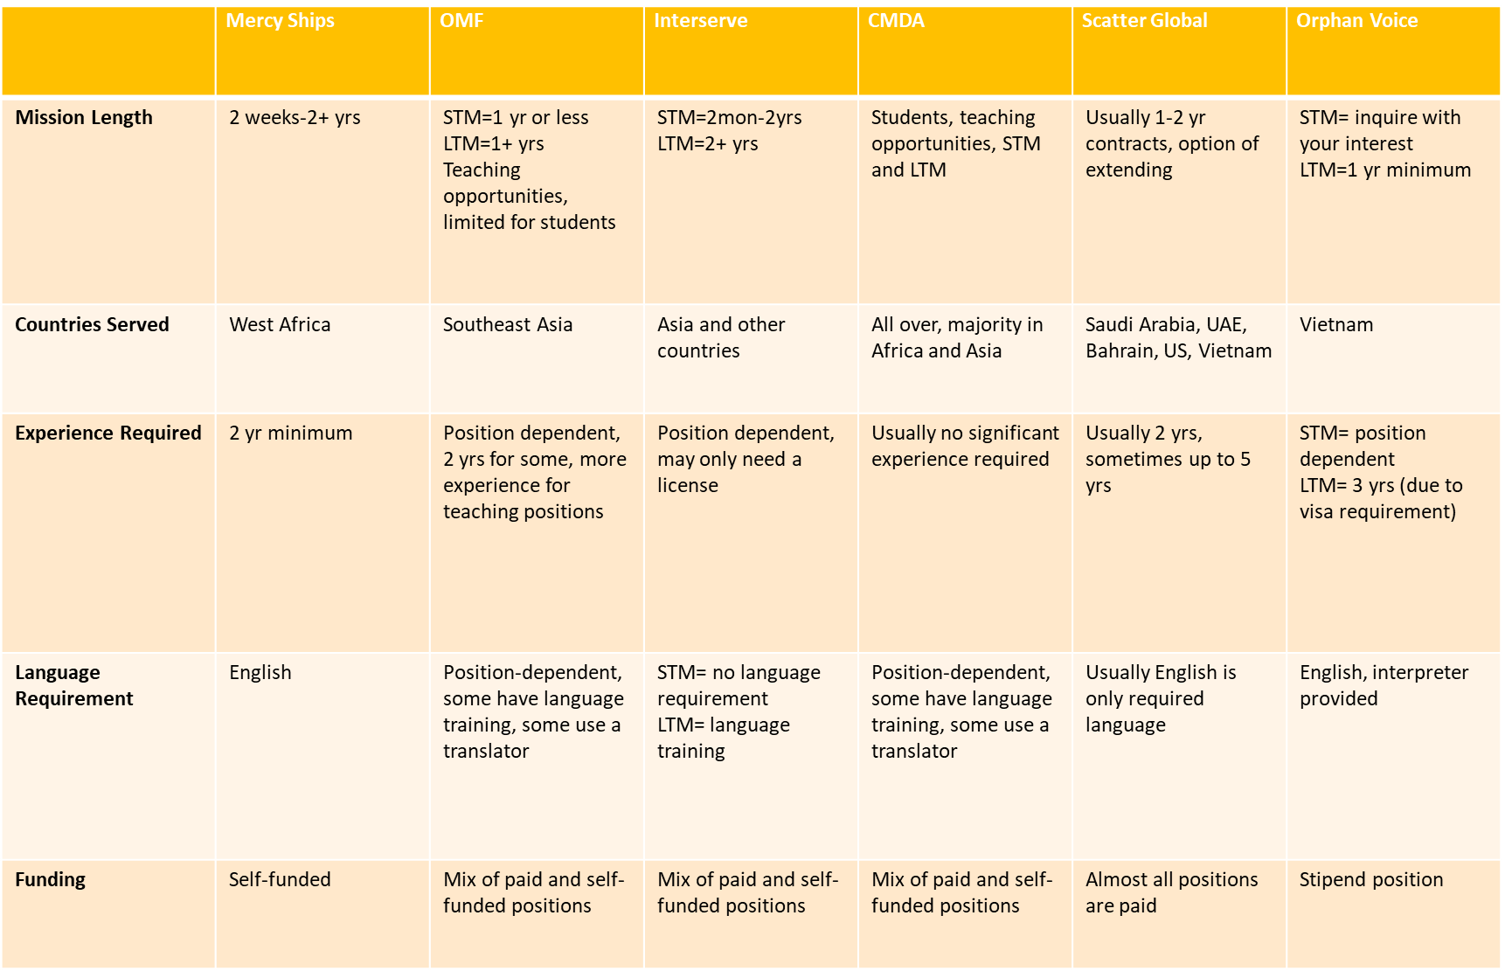

GMHC Resources Link:
https://www.medicalmissions.com/resources
Links to Related GMHC Presentations (sign into GMHC account to access):
- Intro to MedSend - Debt Relief
https://www.medicalmissions.com/resources/5144/intro-to-medsend-debt-relief

- Debt - How to Go Soon and Get It Paid
https://www.medicalmissions.com/resources/25375/debt-how-to-go-soon-and-get-it-paid

- Raising Funds and Overcoming Debt
https://www.medicalmissions.com/resources/10960/raising-funds-and-overcoming-debt

- Removing Educational Debt as an Obstacle to Missionary Service
https://www.medicalmissions.com/resources/7397/removing-educational-debt-as-an-obstacle-to-missionary-service

- Fundraising in a Post-COVID World
https://www.medicalmissions.com/resources/24953/fundraising-in-a-post-covid-world-free-webinar

- How to Integrate your Profession with your Faith
https://www.medicalmissions.com/resources/25419/how-to-integrate-your-profession-with-your-faith

- Spiritual Preparation for Missions
https://www.medicalmissions.com/resources/17746/spiritual-preparation-for-missions

- Preparing For and Working in a Therapy Clinic- Short Term
https://www.medicalmissions.com/resources/4472/physical-therapy

- Missions As A Second Career
https://www.medicalmissions.com/resources/17742/missions-as-a-second-career

- Faith vs. Fear
https://www.medicalmissions.com/resources/11007/faith-vs-fear

- God's Guidance and the Missionary Call
https://www.medicalmissions.com/resources/11519/gods-guidance-and-the-missionary-call

- Finding God's Will
https://www.medicalmissions.com/resources/10939/finding-gods-will

- Managing Physical Therapy Needs on the Mission Field
https://www.medicalmissions.com/resources/11512/managing-physical-therapy-needs-on-the-mission-field

- Why You Should Consider Living Cross Culturally Now
https://www.medicalmissions.com/resources/16966/why-you-should-consider-living-cross-culturally-now

- Short Term Opportunities for OT, PT, SLP
https://www.medicalmissions.com/resources/18459/short-term-opportunities-for-ot-pt-st

- Market Place Workers
https://www.medicalmissions.com/resources/7361/market-place-workers

- Global Trends for Marketplace Workers
https://www.medicalmissions.com/resources/17556/global-trends-for-marketplace-workers

- Marketplace Healthcare Professionals in Closed Countries
https://www.medicalmissions.com/resources/11004/marketplace-healthcare-professionals-in-closed-counties

Podcasts:
- Website of Compiled Sources: https://askamissionary.com/resources-mission-blogs-and-podcasts/
- Alliance for the Unreached Podcast: https://alliancefortheunreached.org/podcast/?tag=missions
- MedicalMissions.com Podcast: https://www.medicalmissions.com/podcast
- CMDA Matters Podcast: https://cmda.org/cmda-podcasts/

GMHC Blog Posts:
- Full Time Missionary Jobs
https://www.medicalmissions.com/resources/26035/full-time-missionary-jobs

- 5 Things to Consider When Reviewing Medical Mission Organizations
https://www.medicalmissions.com/resources/24973/medical-mission-organizations

- Asking the Right Questions: 12 Questions Medical Missionary Candidates Need to Ask Before Deciding on a Sending Organization
https://www.medicalmissions.com/resources/15619/asking-the-right-questions-12-questions-medical-missionary-candidates-need-to-ask-before-deciding-on

Other Medical Missions Conferences:
- Mobilizing Medical Missions (https://m3missions.com/)
- CMDA Conference Links (https://cmda.org/conferences/)

Lisa, OT in Peru:
- First Blog: https://therapyforperu.weebly.com
- Current Blog: https://www.cleverandlisa.com

Caroline Mrowiec, OT, served in Vietnam:
- Website to book series and blog posts: https://voicesofhopebook.com

YouTube Channel:
- Medical Missions TV: https://www.youtube.com/c/MedicalMissionsTV/featured

Perspectives Course (exhibitor at GMHC):
- https://www.perspectives.org/

Financial Assistance:
- Fundraising Coaching: https://tailored.fund/
- CMDA Scholarships: https://cmda.org/mission-scholarships/
- Public Service Loan Forgiveness: https://studentaid.gov/manage-loans/forgiveness-cancellation/public-service
- Income Driven Repayment Plans: https://studentaid.gov/manage-loans/repayment/plans/income-driven
- MedSend: https://medsend.org/
  - MedSend Associates:
    - Africa Inland Mission
    - Antioch Ministries International
    - Assemblies of God Healthcare Ministries
    - Association of Baptists for World Evangelism
    - Baptist Mid-Missions
    - Beyond
    - Brethren in Christ World Missions
    - CAMA Services
    - Christian Community Health Fellowship (CCHF)
    - Christian Health Service Corps
    - Christian Missionary Fellowship International
    - Christian Veterinary Mission
    - Church of the Nazarene
    - CornerStone International, Inc.
    - Cure International
    - CrossWorld
    - Eastern Mennonite Missions
    - Free Methodist Church of North America
    - Frontiers
    - Global Frontier Missions
    - Global Outreach International
    - Global Partners
    - Go To Nations
    - Health Talents International
    - Hope Matters International
    - In His Image
    - International Ministries – ABC/USA
    - International Mission Board, SBC
    - InterServe, USA
    - Kids Alive International
    - Medical Ambassadors International
    - Mission to the World (PCA)
    - Mission: Moving Mountains (n/k/a Discipling for Development – A ministry of The Navigators)
    - OMF International
    - One Collective
    - PIONEERS
    - Reach Beyond
    - ReachGlobal
    - Seed of Hope
    - Serge
    - Shepherd's Staff
    - SIM USA
    - Society of Anglican Missionaries and Senders (SAMS)
    - T.E.A.M.
    - Team Expansion
    - The Luke Commission
    - The Navigators – Discipling For Development Ministry
    - TMS Global
    - TSC Missions
    - World Gospel Mission
    - WorldVenture
    - Wycliffe Bible Translators, Inc.

Communication Applications:
- WhatsApp, Google Voice (option to port your US number), Facebook Messenger, Viber, Google Meet, Zoom, FaceTime, Skype, House Party

International Health Insurance:
- https://www.regencyforexpats.com/HealthInsurance/index

US Embassy STEP Enrollment:
- https://step.state.gov/

VPN Option:
- https://nordvpn.com/

Continuing Education Online Courses:
- https://summit-education.com/

Expat Insider (information for people moving overseas):
- https://www.internations.org/expat-insider/2021/

World Safety Statistics:
- Christian Persecution World Watch List:
https://www.opendoorsusa.org/christian-persecution/world-watch-list/
- Global Peace Index 2021:
https://www.visionofhumanity.org/wp-content/uploads/2021/06/GPI-2021-web-1.pdf
- Most Dangerous Countries:
https://worldpopulationreview.com/country-rankings/most-dangerous-countries
- COVID travel restrictions: https://www.kayak.com/travel-restrictions

Caroline Mrowiec, OTR/L, Contact Information: cmmrowiec@gmail.com

Medical Missions Groups:
https://www.medicalmissions.com/groups: Allied Health Professionals and Students (pending approval)

