](https://www.blogger.com/blog/post/edit/3634161997997057932/5593494364811940114)

Does your child struggle with handwriting?  Or do they hold their pencil with their whole hand, hold their pencil tightly, or just in an awkward manner?  Many kids struggle with grasp, but there are also many ways to help.

Hi, I am Betsy, retired O.T, homeschooling mom and veteran homeschool blogger from [BJ’s Homeschool](http://www.bjshomeschool.com). Many kids struggle with learning to write. I think the best way to help them is through fun playful handwriting activities.

Here’s 8 playful ways to help your child develop the mature grasp pattern that will make their handwriting so much easier. I recommend starting with just one activity that you think your child would like.

**What is a Mature Grasp Pattern?**

Little kids will naturally begin coloring by holding the crayon with the whole hand.  This is normal for preschoolers and many kindergarteners, too. Some kids will gradually move to a mature grasp pattern over the years, as they grow, but many don’t. As you see in the photo below, a mature grasp looks like this:

](https://www.blogger.com/blog/post/edit/3634161997997057932/5593494364811940114)

Photo Credit – [Draw Your World](http://www.drawyourworld.com)

|  |
| --- |
|  |

Using other grasp patterns, such as these below, are common as your child begins to learn a mature grasp.

|  |
| --- |
| [A picture containing text, sketch, handwriting, drawing  Description automatically generated](https://www.blogger.com/blog/post/edit/3634161997997057932/5593494364811940114) |
| Photo Credit – [Draw Your World](http://www.drawyourworld.com)  These are quite uncomfortable, and often occur from using excessive effort.  As the child practices, they will most likely begin to relax.  And the best way to relax is to play! So try these fun activities below. He  **Color Crayon Trick** |

](https://www.blogger.com/blog/post/edit/3634161997997057932/5593494364811940114)

Coloring with very short crayons can encourage your child to use his first three fingers, instead of the whole hand! *When coloring with short crayons, there is more of a chance that your child will grip with the first three fingers only. There is no room for the other fingers to fit on the crayon! Draw away!*

**The Puff Ball Trick**

](https://www.blogger.com/blog/post/edit/3634161997997057932/5593494364811940114)

First, get a pencil and a little puff ball, or a cotton ball, or even a small eraser. - Have your child hold the puff ball with their little and ring fingers, curling the ball into the palm. Just practice holding it first.

**Add a Pencil to Puff Ball Trick**

](https://www.blogger.com/blog/post/edit/3634161997997057932/5593494364811940114)

 Then give a your child a pencil or a crayon, *and they will likely grasp it with the thumb, and next two fingers. Coloring or drawing in this manner is a great way to learn the mature grasp.*

**Alligator Fingers**

](https://www.blogger.com/blog/post/edit/3634161997997057932/5593494364811940114)

Many kids just love this. Make "alligator fingers" using the thumb, index and middle fingers to make an alligator's mouth, as in the picture above. Do shadow play, pick up small toys using this hand shape. Pinch a clothes pin with your alligator fingers!

**Tweezers Play**

](https://www.blogger.com/blog/post/edit/3634161997997057932/5593494364811940114)

Pick up little things with tweezers, using the first three fingers. Use them to pick up small pieces of macaroni, beans, etc. OR Squeeze glue onto a paper plate, and add macaroni with the tweezers, to make a design!

**Playing with Tongs**

](https://www.blogger.com/blog/post/edit/3634161997997057932/5593494364811940114)

Kitchen tongs are great for strengthening the finger muscles. Have your kids use their alligator fingers. Pick up small objects like Legos, beads, or beans. Or put them into an egg carton, with the tongs, if your child needs another challenge. But the focus is on fun!

**Push Pin Play**

[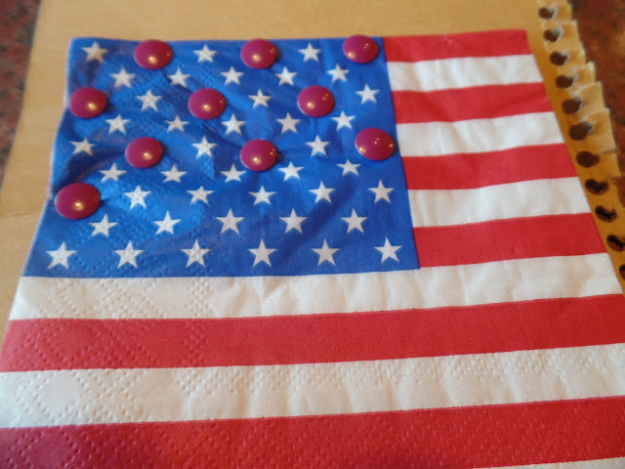](https://www.blogger.com/blog/post/edit/3634161997997057932/5593494364811940114)

Place a paper napkin onto a piece of cardboard. Any paper napkin will do. Then, with the index finger or the thumb, have your child pushes the pins into the napkin to make a design.  This is great for strengthening. Lots of fun with napkins with a picture on them.  

**Playing with Clay**

Playing with playdough is excellent for strengthening. Just have fun with it. Then later, If your child is ready: Pinch the playdough or clay, using alligator fingers. Make a pinch pot! OR make a clay pizza. Add small shapes to it, by squeezing clay to form pepperoni, onions, etc. More ideas here: [**Clay Activities for Handwriting**](https://www.bjshomeschool.com/2018/10/develop-hand-strength-with-homeschool.html)for older kids.