Cultivating a Missions Mindset in Surgical Residency

Recommendations from five active missionary surgeons 2020

FROM MIKE CHUPP: GENERAL SURGEON to ORTHOPEDIC SURGEON to CMDA CEO

I returned from service at Tenwek hospital in Kenya after 20 years, having experienced a productive and satisfying career as a missionary surgeon. One of the main reasons I agreed with Dr. David Stevens to come on board with CMDA National ministry was my desire to give back to future generations of Christians in healthcare a testimony of God’s faithfulness and his blessings for those who are obedient to his call on their lives. My life/ministry theme scripture is from 2nd Timothy 1:6, 7 and the apostle Paul’s admonition to Timothy to “fan into flame the gift of God”. If you are a medical/dental student or resident (whether in surgery or any other specialty for that matter) and would like to talk to someone who has been overwhelmingly blessed, together with my family, by two decades in cross-cultural ministry, I can be reached at [mike.chupp@cmda.org](mailto:mike.chupp@cmda.org). I trust you will find the following five surgeons’ perspective on the cultivation of a missions mindset helpful. Such a privilege to see firsthand from CMDA National office how God keeps “Changing Hearts in Healthcare” until Christ comes back to take us home!

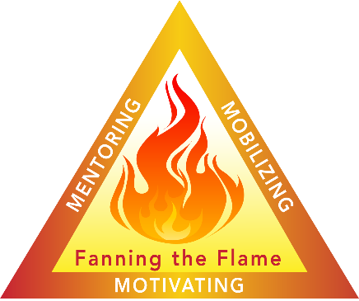

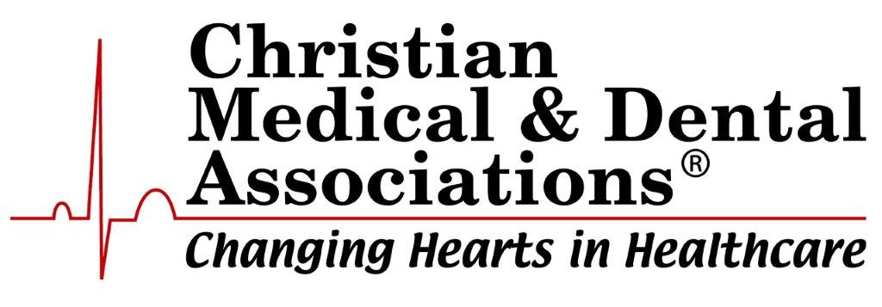

1. Dr. Jason Axt

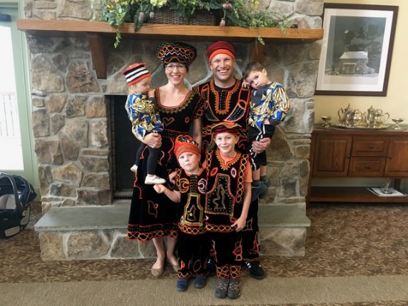Jason Axt is a pediatric surgeon serving at AIC Kijabe Hospital in Kenya.  He completed general surgery training and a Master’s Degree in Public Health at Vanderbilt University Medical Center.  He subsequently trained in  pediatric surgery at Children’s Mercy Hospital in Kansas City.  He has significant research contributions in the realms of global surgery and the treatment of Wilms Tumor in Sub-Saharan Africa.  He and his wife Meridith, have four children.  He and enjoys teaching surgical residents one on one.  He also has a graduate of theology degree from the Calvary Bible Institute.

I’m amazed that we are still in cross cultural missions. My wife and I were thrilled to be following God’s clear guidance to move to Cameroon in 2014. The location was beautiful, the people sweet, and the language English. I loved doing surgery in this place. The residents were fun, but the responsibilities weighed heavily. The other long-term surgeons had to leave for various reasons, and I became the de facto interim program director for the PAACS training program. The surgical load was heavy. With the additional administrative and family needs, the pressures mounted. I felt the weakness of the spiritual training in the program but felt inadequate to make changes. Where was the time? Or energy. In addition, there were interpersonal struggles between the PAACS families and some academic failures amidst the residents. It was amongst these pressures that God really sustained Meridith and I. He had done many things to prepare us. Let me reflect on just a few.

1. Marriage – When I met Meridith, my wife, she had an independent love for and call to long-term cross-cultural missions. We were unified in our desire and plans to work together following him.
   1. Unified Goal
   2. Intentional time – during residency we had two guidelines that we consistently kept.
      1. When I returned for the evening, I sat down for 10 minutes and looked at her and talked about the day.
      2. Monthly we had a planning session – monthiversery in which we talked about each aspect life and discussed them
2. Personal Relationship with God
   1. Though time was short – I kept the habit of spending time in the Word and Praying
   2. I prayed with residents and families routinely – thus my personal relationship with God was also corporate.
3. “What you put in the fridge”
   1. When we discuss how to eat healthy in our home – we discuss buying and placing healthy items in the fridge and in the cupboards. We also do the same with our lives.
      1. Our bookshelves were filled edifying books
      2. We invited people to our home that could fill us spiritually, or those that had open ears to hear about our Lord.
      3. We kept good food in the home.
4. “Ride the Elephant”
   1. When working in the VA hospital as a surgical resident, my program director, John Tarpley, would say “The system is an elephant, you can’t push it or pull it. Usually you must just ride it.”
   2. Surgery in a cross-cultural setting requires a lot of patience. It is okay to work for change and be part of that change, but wait and talk and pray, and pray and talk and wait.
   3. You might make suggestions, advocate for change, push a bit for something different, but then wait on the Lord and the system. Big changes are made incrementally and over time.
5. Wait on the Lord.
   1. God is calling you to himself
      1. Know that your life may be nothing like what you imagine.
      2. We left Cameroon to complete training in pediatric surgery and then went on to France to study French in order to return there.
      3. A conflict made it impossible for us to return.
      4. I am now working in an English-speaking hospital / location
      5. Meridith became very ill with a debilitating pain syndrome while in France
   2. My plans were not Gods.
      1. Wait on Him.
      2. The story is His. He wants you to be part of it.
      3. Whether in long-term cross-cultural missions or in intra-cultural missions – he is calling you on Mission.
      4. Follow him into uncertainty. We can trust Him.

*How do you maintain a calling to a place you've never been and a work you've never done, through long years of training?  I was 16 when the Lord called me to missions in a Muslim nation, and I did not set foot in my 'long term assignment' for another 15 years.*

*We think of a calling as an act of service - a calling To Somewhere or For Something.  But at the heart of every true calling is a calling to a dynamic relationship with Christ, and every other calling is secondary to that.  And so the number one thing I did to maintain my calling to ministry was to pursue Christ.  I chased Him, studied Him, wrestled with Him, screamed at Him.  I worshiped Him, waited on him, and learned the adventure of obedience that makes no sense to me.  I asked him questions - millions and millions of questions, multiple every day.  Questions like 'How should I answer this?' and 'What do I do about that?' and 'What on earth did you do THAT for?'  And in the process I learned to know him, personally and deeply.*

*When our primary calling to this knowledge of Christ is right, our secondary callings - to service, to mission, to ministry - will fall into place. The desire, the skills, the timing, and the direction will be led by a Father who never makes mistakes.*

*There were other things, too, of course. I learned to approach every location as my calling.  Yes, I was called to Muslim ministry, but there weren't very many Muslims in my residency program - and there* were *a lot of Hispanic immigrants and medical students.  So I approached those people as my mission field.  I didn't learn 'missionary-ness' on the other side of the world.  I learned it at 3am on a busy call night: when I struggled to pray for patients in Spanish, when a student started asking deep questions, when a colleague wept on the call room couch... and I learned it because I took my calling into that non-Muslim space and gave it space to flower.*

*I traveled whenever I had an opportunity.  I read books.  I prayed for the nations.  I dreamed.  These things are helpful.  But they're not as important as seeking Christ first.*

3. Dr. David Jeffcoach- General surgery

In 2004 I felt a divine call to pursue medicine for the specific purpose of missions. I graduated from surgical residency in 2016 and then trauma and critical care fellowship in 2018. By the time I finished fourteen years removed from “the call” I had nearly zero interest in missions and accepted an academic appointment in trauma surgery. To be frank, I did not cultivate a missions mindset during residency. Those were the hardest years for my walk with Christ, my marriage, and my family. Surgical training, for me, was a spiritual desert.

Today my family and I are serving in Soddo, Ethiopia, and work with PAACS training and discipling African surgeons for Africa. While I lost my way, the Lord directed my steps. If you are listening to this presentation, you are amongst a very few who even entertain missions in the surgical field. There are an untold number of obstacles to keep you from ever reaching your goal. Here are a few things that were critical in my journey from pre-med to full time missionary surgeon. First, my wife is likeminded. The road is so tough you must share the vision for missions. This is the most common reason cited by other surgeons I’ve met who never went. Second, we lived counter culturally during training. We lived modest, payed loans down, drove old cars, and took cheap vacations. Next, we went to GMHC three times throughout training. In these brief times we remembered the call. You need to surround yourself with opportunities to remember the call. Further, own the vision. I wish I would have done this better. Tell the other residents and faculty, ask people to pray for you, make it your identity. Last, pray and fast. Our decisions of where to do medical school, residency, fellowship and ultimately the way we walked away from it all was through prayer and fasting. I lost the vision but in hindsight each step uniquely prepared me for what I am doing today.

Every month PAACS issues a newsletter. If you read the prayer request and needs at the end you will see the biggest need month after month is for surgeons to join full time. There are only about twenty foreign missionary general surgeons across nine programs in PAACS. There are currently 18,000 general surgeons in America. Think about that! Why? Everything will be against you. Family will say you are crazy. You’ll walk away from a salary that you believe you deserve during some of the most productive years of your career. Your colleagues won’t understand. You will have a mountain of debt. If you are like me, you may have to leave your “dream job”. But, we only live once and we will have to account for the way we spent our fleeting years on this earth. Live bold. Tune out the noise. Don’t believe the crowd. I tell my wife all the time that living and working in Soddo is the best job I’ve ever had. The rewards are both eternal and temporal. “Therefore, since we have so great a cloud of witnesses surrounding us, let us also lay aside every encumbrance and the sin which so easily entangles us, and let us run with endurance the race that is set before us, fixing our eyes on Jesus…” Hebrews 12:1.

4. Dr. Michael Ganey – Pediatric Surgery

**Persistence in Following**

Clear call (to medical missions, where less so for me)

Spouse with shared vision/calling

* waiting for one another to agree on big decisions (I felt God calling us to Tenwek a year before Julie did. Waiting patiently for us to be in agreement was one of the best decisions I’ve ever made. I’ve seen others mess this up with bad results.)
* Guarding my heart beforehand
* #1 most common “I would have been a medical missionary but...”

Advice from Tom and Cynthia Hale (as I remember it)

* most missionaries only last two years
* survive the first term with the desire to go back

Devotion to Jesus above all else

* daily QT
* Keep on asking, keep on seeking...
* A whole lot of grace for all of my failures

First, I would recommend seeking out cross-cultural experiences during residency. It may be befriending staff or co-workers at your hospital who are from a different ethnicity or culture and learning about their culture. It may be serving refugees or other populations within your city who are from a different cultural background. Going on short-term trips is great as well, but you can learn a lot and start engaging in cross-cultural missions right where God has placed you. If you know or can network with current/retired medical missionaries, that is also a huge benefit to hear their first-hand stories. Books that I found helpful: Foreign to Familiar by Sarah Lanier; Cross-cultural Servanthood by Duane Elmer; Serving with Eyes Wide Open by David Livermore.

Secondly, Learn to pray with patients and share your faith. If you can't share your faith in your own culture, how will you do it cross-culturally? Learn to identify "faith flags", ask questions with a concern for where the patient is at in their own faith journey and gently point them closer to God. Stand firm for your faith, your integrity, and your moral values amongst co-workers and attendings. Don't be obnoxious, just remain faithful to what you know to be true. Helpful resources: Grace Prescriptions Course available through CMDA; Gray Matter by Dr. David Levy.

Third, Do not neglect your relationship with God in the midst of the busy-ness of training. You make time for the things you value. Make God your priority. Gather with a community of worshippers regularly, meditate on the word and pray on your own, listen for God's spirit to lead and direct you. Practice the presence of God. Lean into God through all the ups and downs of residency. Nothing will prepare you more for the mission field than having a solid relationship with your loving Father. When all else is stripped away, He alone remains and He is all that matters in the end. Books I recommend:  Practicing God's Presence by Brother Lawrence (ed by Robert Elmer for today's reader); Celebration of Discipline by Richard Foster

Factors Critical to Maintaining the Call:

1. A strong sense of God's leading and call to missions. If God is calling you, he will sustain you. Don't go in your own strength or for your own motives.

2. Strong personal faith and relationship with God (see above). Apart from the vine you will not produce fruit; moreover, you will wither and dry up without the life-giving spirit that comes from abiding in Christ. Place  worship and practicing his presence above your "service" to him. God before work or ministry or family or any other obligations.

3. Prayer warriors. It is imperative to have a strong team of prayer warriors covering you and your ministry in prayer. Communicate with them often and openly about your joys and struggles so they know how to pray. Identify a select group of intercessors that you can contact any time of night or day when urgent/emergent prayer requests arise.

4. Community. Having a supportive community (whether on location or back home) with whom you can share life and laugh and cry and "be real" is very important for mental and emotional health. I personally benefit from having 1 or 2 confidantes whom I trust and who help me debrief after a stressful day/week.

5. Maintain appropriate expectations. My biggest frustrations stem from having unreal expectations of myself and others. Unreal expectations for how quickly I will culturally adapt or learn a new language. Unreal expectations of the speed and efficiency (or lack thereof) at the hospital and how difficult it is to institute change. Unreal expectations of how difficult it is to minister cross-culturally in a language you are barely proficient at. Unreal expectations of how many patients you can safely see and treat in a day. Unreal expectations for how you will cope with death and difficulties outside of your control. Expect that things are going to change, frequently. Expect that you will have to continue learning and adapting, even after you've been on the field for years. Expect that you will not be enough: you are not strong enough, smart enough, or prepared enough. And that is okay. God is more than enough. We have this treasure in jars of clay to show that this all-surpassing power is from God and not from us. Expect to be stripped bare of all that you once though was important until all you're left with is Christ. Expect to see God working in seemingly small but miraculous ways when we surrender completely to him.

6. Rest. Time off from work. Time away from the hospital and station/compound where you live/work. Times of solitude and reflection. Times of spiritual retreat. Don't feel guilty for leaving the work.