Single Women
A Big Change
Moving to a segregated country, where women are banned from driving or even conversing with a single man, can be intimidating. It is important to prepare yourself mentally for a move like this. Many times the expectations developed from television and the news do not represent what daily life is like for an expat in Saudi Arabia. Seek the insight of those around you who have lived in the Middle East to get a better idea of what life there might be like for you.

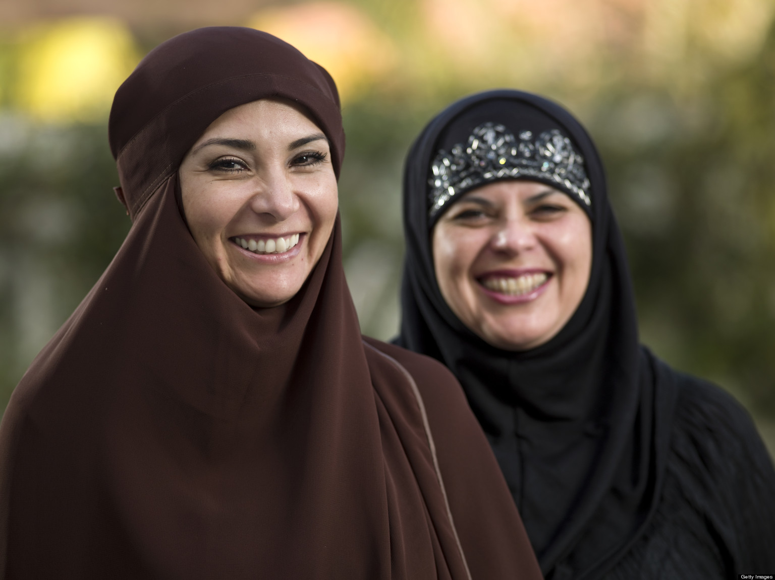

Making Friends
Life as a woman in Saudi Arabia can be challenging – life as a single woman in Saudi Arabia can feel impossible. There are many obstacles you must overcome and cultural differences you must accept, yet being a single woman in the Arab world has its advantages. You are free to invite other women to your house to get to know them. Many Saudi women are also single and the expat community is growing, so there will always be plenty of people to meet.

Clothing
One common obstacle for women in Saudi Arabia is clothing. Women are required to wear a hijab, or head covering, and a black abaya, which is a long, loose-fitting gown when outside of the home. In the more conservative towns, you must also wear a face covering called a niqab. In expat communities, these rules tend to be more relaxed.

Driving
Women are not allowed to drive in the Kingdom. This can cause issues for single women without a man to drive them. It is common for sponsors to provide transportation to women in their workforce or for women to hire personal drivers for daily use.

Living Arrangements
Proprietors will not rent a house to a single expat woman, so many women who move to Saudi Arabia are generally provided with accommodations in a compound by their work sponsor.

Support system
It is important to find a support system upon arrival in the Kingdom. Married people are held at a higher regard than single women, so it can be discouraging at first without the right people. Seek the encouragement of other women to build meaningful relationships.

