Human Trafficking: Developing Awareness and Education
Sherry-Ann Brown, MD, PhD; drbrowncares@gmail.com; @drbrowncares; www.drbrowncares.com

Isaiah 61:1-2: “The Spirit of the Lord GOD is upon me, because the LORD has anointed me to bring good news to the afflicted; He has sent me to bind up the brokenhearted, to proclaim liberty to captives and freedom to prisoners; to proclaim the favorable year of the LORD and the day of vengeance of our God; to comfort all who mourn…”

Objectives
1. Recognize the need for healthcare professionals to be educated on human trafficking

2. Be able to create materials to raise awareness regarding human trafficking

3.Be prepared to educate oneself and others in depth on human trafficking

ACTION POINT: What is your role as a Christian healthcare professional

regarding raising awareness of human trafficking among your professional colleagues?

Resources for Materials to Raise Awareness
Department of Human Services Blue Campaign: 1-888-3737-888
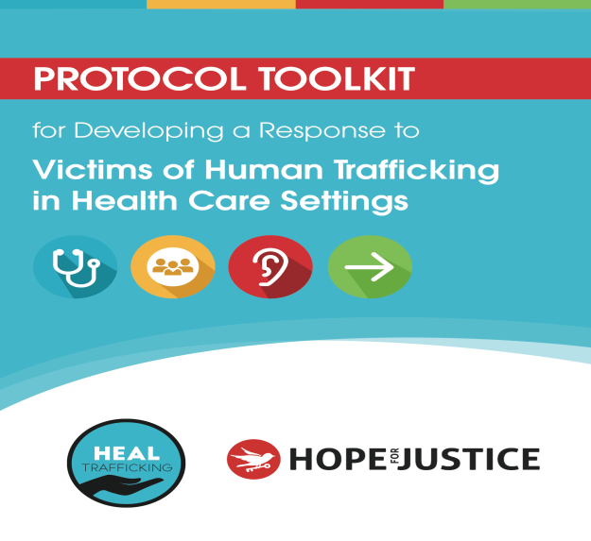
https://healtrafficking.org/linkagesresources/protocol-toolkit/
www.houseofhopenicaragua.com

Books: Not for Sale, Girls Like Us

Videos of Dr. Sherry-Ann Brown

1. “TEDxZumbroRiver Pitch Night 2017 - Sherry-Ann Brown"
https://www.youtube.com/watch?v=bcR7szZj9-I
2. “A few Thoughts on Human Trafficking” by Dr. Sherry-Ann Brown
https://www.youtube.com/edit?o=U&video_id=fckdKmyGgyQ

Medical Education
Intro to Domestic Human Trafficking in the US Module for HCP
CMDA Human Trafficking Online CME
American Medical Association News Article
Human Trafficking Info Sheet (from Blue Campaign) https://healtrafficking.org/linkagesresources/protocol-toolkit/
"For the things we have to learn before we can do them, we learn by doing them." ~ Aristotle
REFERENCES by Dr. Jeffery Barrows
1. International Labor Organization. “ILO Global Estimate of Forced Labor”. (2012) http://www.ilo.org/global/topics/forced-labour/lang--en/index.htm.
2. International Labor Organization. “Profits and Poverty: The Economics of Forced Labour.” (2014). http://www.ilo.org/wcmsp5/groups/public/---ed_norm/---declaration/documents/publication/wcms_243391.pdf
3. Williamson, C., Perdue, T., Belton, L. et. al. “Domestic Sex Trafficking in Ohio: A Study of Five Ohio Cities”. (2012) Research and Analysis Sub-Committee Report of the Ohio Attorney General’s Commission to Study Human Trafficking.
4. Chisolm-Straker, M., Baldwin, S., Gaigbe-Togbe, B. et. Al. “Health Care and Human Trafficking: We are Seeing the Unseen.” J Health Care for the Poor and Underserved. (2016). 27(3):1220-1233.
5. Lederer, L. and Wetzel, C.A. “The Health Consequences of Sex Trafficking and Their Implications for Identifying Victims in Healthcare Facilities”. (2014) The Annals of Health Law 23:1. 61-91.
6. Chisholm-Straker, M., Richardson, LD., and Cossio, T. “Combating Slavery in the 21st century: The role of emergency medicine.” (2012) J Healthcare for Poor and Underserved 23:980-987.
7. Baldwin, SB, Eisenman DP, Sayles JN et al. “Identification of Human Trafficking Victims in Healthcare Settings”. Health and Human Rights (2011) (13) 1:1-14.
8. Hemmings et al. “Responding to the health needs of survivors of human trafficking: a systematic review”. BMC Health Services Research (2016) 16:320 DOI 10.1186/s12913-016-1538-8.

